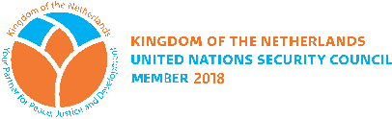
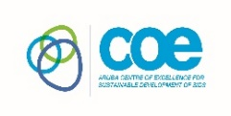
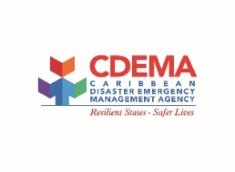
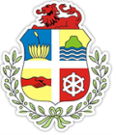
Planetary Security in the Caribbean Region: A Roadmap to Climate Resilience
Working Group Guidelines

- Meeting participants will be organized into six (6) working groups and a group facilitator has been identified for each group.
- Each group should select a rapporteur
- Each group will be provided with a reporting template in digital format for completion
- Each working group will focus discussions around the priority areas within the Draft Plan of Action as follows:
  - Group 1: Strengthening Capacity and Knowledge on Climate and Security in the context of Caribbean SIDS
  - Group 2: Strengthen regional coordination in support of humanitarian crises
  - Group 3: Advance Food Security within the Context of a Changing Climate
  - Group 4: Strengthen Water Security in the Context of a Changing Climate
  - Group 5: Advance the Renewable Energy transition of Caribbean SIDS within the Context of a Changing Climate
  - Group 6: Advocate for stronger political support for the Regional Climate and Security Agenda
- For each of the areas identified above, the facilitator will guide the group discussions using the following instructions:
  - Review the language of the priority area within the action plan. Discuss and make any recommendations for amendment.
  - Review the brief description associated with the priority action and make any amendments.
  - Discuss the actions recommended under the priority area. Make recommendations for additions or amendment.
  - Recommend lead agencies, timeframes and if possible estimated budgets and sources of funds.

