Logo Rationalisation
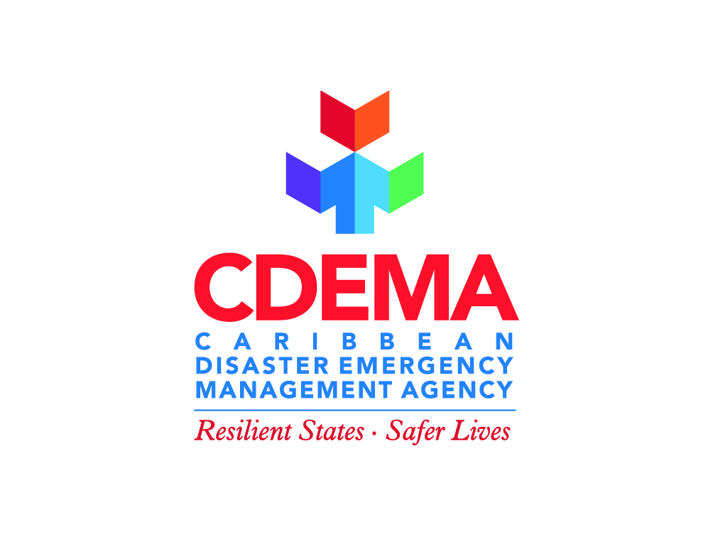
Building Blocks:
The building blocks symbolise strength, growth, openness and purpose. The incorporation of these blocks, a key feature in the previous CDEMA logo, is nostalgic. As we usher in a new era, the blocks keep us ever mindful of our past and the continual contributions of our stakeholders to the Agency’s success.
Colours:
The bright hues of orange, red, purple, blue and green are the embodiment of the Caribbean Spirit and the diversity of our people and our culture. Disaster Management is often perceived as “Doom and Gloom”. The vibrancy of these colours represents hope and is therefore also symbolic of the Agency’s thrust in building a culture of resilience within the Caribbean.
Font:
A sans font is utilised in the logo text. The straight, thick lines denote strength while the rounded letters represent warmth and humanity.
Tagline:
The CDEMA logo appears with the tagline – Resilient States. Safer Lives. This tagline captures the reason for our existence. Our highest calling is the protection of the lives and livelihoods of our people and the building of a safer, more resilient Caribbean.

