RAPID ASSESSMENT REPORT FOR ST. VINCENT AND THE GRENADINES
Prepared by Regional Health Response Team

EVENT: Flooding and Landslides from Trough System
EVENT DATE: 24-25 December, 2013
ASSESSMENT PERIOD: 29thDecember – 2nd January, 2013
LOCATION: St. Vincent and the Grenadines
SECTOR: MOH/PAHO Health Sector Assessment
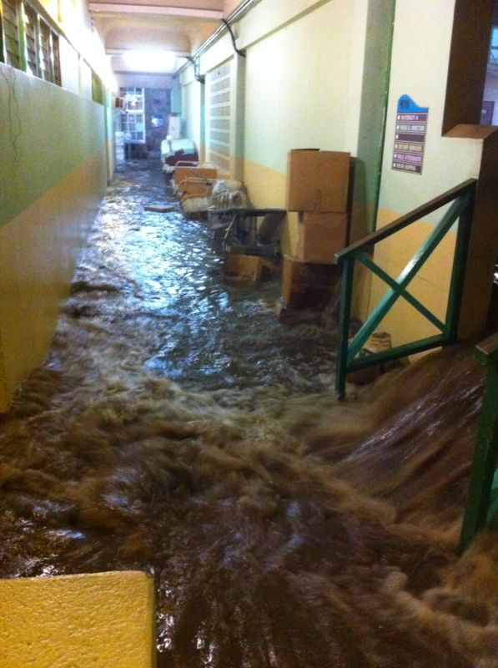
Flooding occurred on 24thDecember, 2013 as a result of 3.11 inches (79.22mm) at E.T. Joshua Airport, as reported by the Met Office. 9 persons have been confirmed dead and 3 are missing. 50,000 people are without water. The government declared a Level 2 disaster.
No warning was received therefore no response procedures were activated to assist in securing patients, clearing drains, safe guarding equipment and supplies. Of the 109,373 persons residing in St. Vincent and the Grenadines, 13,029 persons have been directly affected in the disaster declared areas; 500 persons have been displaced island wide; 200 in shelters. 30% of potable water supply was available to the population after the impact, 50% to date and it ais projected that by Tuesday 31st 85% of the population will be able to access the water supply. No information on water quality is available as yet.
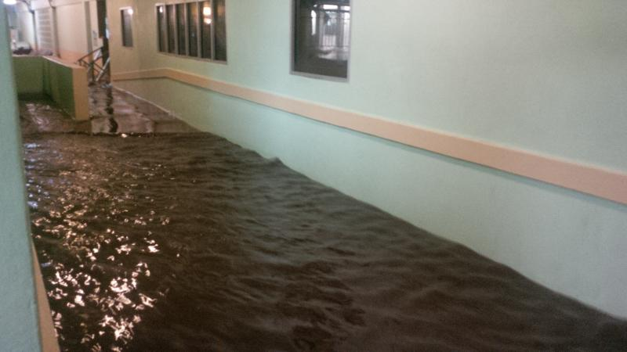
The Road Network has been severely compromised especially on the windward and leeward side of the island. Access to health facilities in the impacted areas is limited.
The Ministry of Health operates 39 district clinics, 1 polyclinic, 5 district hospitals, I referral hospital, 1 facility for the elderly and indigent, and 1 mental health facility
Most affected areas of the health sector are the Milton Cato Hospital (referral hospital with 215 bed capacity) and 3 clinics. As of today 29 December 2013 50% of population is without potable water supply and there are potential risks for dengue and water borne diseases.
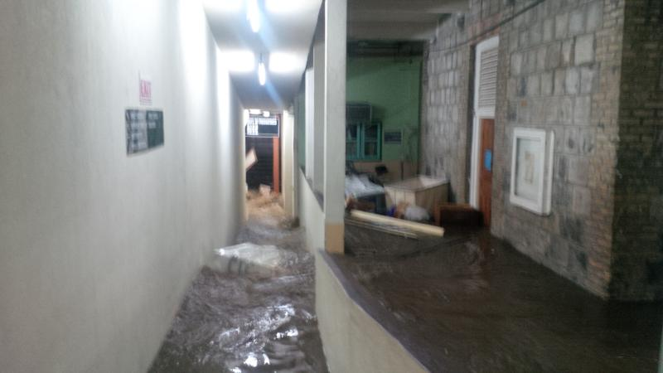
There have been no reports on damage on the Grenadine Islands.
Whilst damage to roads and bridges is significant, the reduced capacity of Milton Cato Memorial Hospital will affect the total population of the country as it is the only referral hospital serving St. Vincent and the Grenadines.
Plans for a new hospital are still in the feasibility analysis stage and thus may take some time before a new facility becomes a reality.
Milton Cato Memorial Hospital
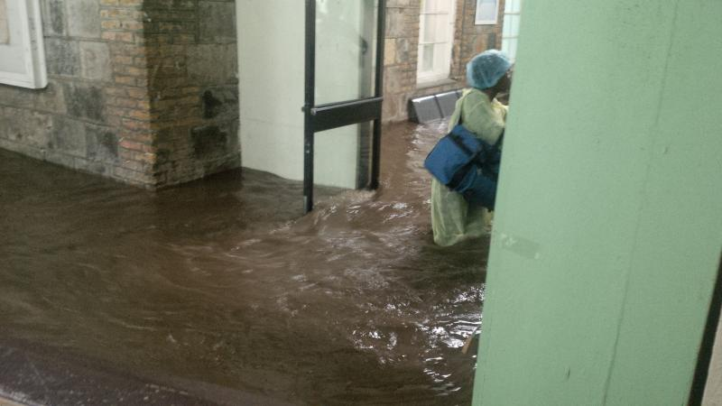
Due to lack of warning, maintenance staff was not available in the hospital at the time to initiate the flood response procedures such as lifting the covers and clearing the drains that run through the hospital. The hospital is located in a flood plain and is being affected by development on hillsides that channel storm water into the flood plain.
Access to water in the hospital is limited, 2 tanks are available however capacity is only for 24 hours. No pumps exist to refill tanks from portable water supply trucks. 15 persons were seen at Accident and Emergency, 5 were admitted and 7 provided with psycho-social support on the day of the floods. (On December 26th the Psychosocial Team of the Ministry of Health partnered with the team from the Ministry of Education to provide support to the persons affected in the heavily impacted Pembroke District.) Plans for providing ongoing psycho-social support to the community are being developed.
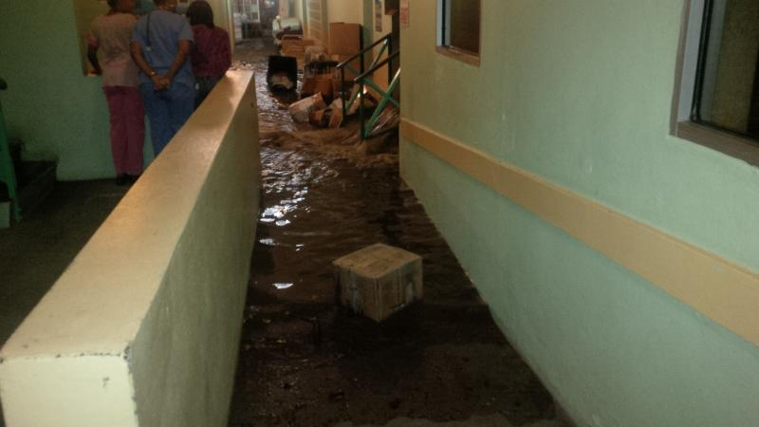
Current patient load in the hospital is 72 and the Morgue is filled to capacity. This hospital is operating at 60% capacity. The usual occupancy of the hospital was 90-100%.
At Milton Cato patients have been evacuated from maternity, male medical, and pediatrics including the neonatal ICU, which resulted in approximately 86 beds being lost.
The estimated damage cost for Milton Cato Memorial Hospital is USD$314,210.85.
Location | Summary of Damage
Administration Block | Damage sustained to Administration Block that houses the Accounts and Records Departments. Damage was mainly to furniture, records and electrical systems.
Central Sterilizing Department | Basic Supplies lost  Autoclave (standing unit) was impacted however a small unit is available but insufficient.
Maternity A | Flooded resulted in damage to electrical beds, outlet damage, furniture damage, 110 transformer, power supply to the CCG (to monitor contractions)
Director’s Office | Electrical supply impacted
Female Surgical Wing | Houses the bulk storage – to date 4 truckloads and 7 skips of damaged supplies and equipment have been cleared from this location and discarded
Records Room | Numerous records of patients prior to 2012 water damaged
Lecture Room | Electrical assessment required, transformer impacted as well as refrigerator
Physiotherapy | CT scan machine impacted by flood waters and is currently being assessed to determine extent of the damage. Water levels in this location were about 12-15 inches in height. Technicians are expected to complete assessment of the CT scan shortly.
Maintenance Department | A detailed listing of losses is available and other areas are being assessed.
Pediatric Ward | Losses to drugs, medication trolley, paper and incubators
Male Medical Ward | Total wash out of supplies
Corridors | Total Wash out and impact to all equipment and supplies stored in these locations
Kitchen | This area has been relocated to the hostel in Stoney Grounds
Oxygen Plant | Plant has shut down and is not operational; air compressor may have to be replaced. Cylinders are available from a local company

Chateaubelair Hospital
15 persons were seen at this facility; water supply is limited and tanks are too small to service the facility adequately. This Hospital has a bed capacity of 20 and at the time of the event there were 4 patients
No electricity supply was available from 25-27 December, 2013. Access to this facility was limited and a make shift casualty was set up at Rose Bank in a private home. The facility was not flooded. To be updated following site visit tomorrow
District Clinics
Pembroke, Buccament, and Clare Valley clinics were flooded
Fancy Clinic – the area is only accessible by helicopter. There has been significant road damage in this area, no access to water and 1 casualty reported (a man washed out to sea but recovered)
All clinics and hospital were mandated by the Ministry of Health to continue operations. Water supply is being provided by the Central Water and Sewerage Authority (CWSA) and water containers have been provided for storage. To be updated
PAHO Proposed Actions for Follow Up
For Milton Cato Memorial a rapid assessment was performed and a needs list prepared and made available to the MOH.
Direct Assistance to the hospital is needed to restore functionality and ensure access to health care.
Priority Areas
- Address Public Health concerns - including records management and health promotion – concerns regarding mosquitoes/dengue, mold and water quality.
- Direct Assistance to Milton Cato for Clean Up – availability of basic supplies lost (3 months of supplies lost)
- Establish emergency storage for supplies and water - procurement of 40 ft containers (2) for storage of supplies and large water tanks (1000 gals each). For Milton Cato Memorial 12,090 liters of water per day is needed for the 215 bed hospital (60 liters per bed estimated). Water storage containers will also be necessary for the clinics.
Rapid assessments and immediate needs lists for Milton Cato Hospital are available at the appendices.
Summary for Milton Cato Memorial Hospital
- No structural damage was observed to the Milton Cato Memorial Hospital, however reviews of drainage system and disaster plans are recommended.
- Non-structural/Functional:
  - Hospital needs to be urgently cleaned.
  - Substantial losses to medical equipment and supplies, which are affecting the daily operations of the hospital and the support that they provide to the 5 district hospitals, needs to be replaced urgently.
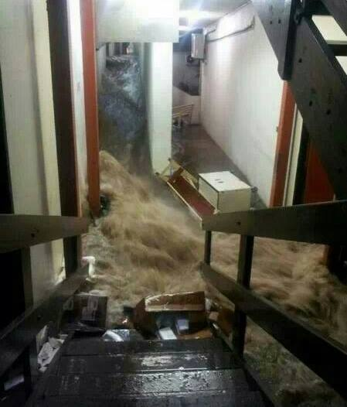
- Electrical systems experienced significant damage and needs to be assessed in detail and rehabilitated with special considerations to safety procedures, such as a kill switch.
- Based on recent weather patterns and climate change, it is highly probable that there will be future such events. Mitigation measures should be implemented as soon as possible, including the relocation of medical storage supplies to a safer location, less prone to floods.
- There is a need for the hospital to consider cross training among staff to ensure that many persons are available to respond to critical actions such as turning off breakers, lifting drainage covers etc.

APPENDIX 1 – Rapid Assessment for Milton Cato Memorial Hospital
STRUCTURAL
- There was no direct structural impact observed, as a result of the floods.
- There is currently a primary surface runoff drainage culvert that runs through the hospital, under the A&E department. The original hospital was built about 100 years ago, but various additions and extensions have been done since, including the A&E and OPD department, which were done in 1995. No as-built drawings were available, however architectural drawings were reviewed.
- The rectangular box culvert is about 1000mm wide by 600mm deep. The large volume of water easily overflowed the existing culvert and debris from the floods also blocked the drainage outlets downstream of the hospital and further exacerbated the situation.
- The departments of the ground floor which were directly impacted were:
Department | Flood Water Level
Accounts & Records | 150mm to 400mm
Central Sterilization Services Department (CSSD) | 450mm to 600mm
Maternity A | 600mm
Female Surgical Wing – where medical supplies were being stored | 600mm to 700mm
Physiotherapy | 200mm to 300mm
CT Scan | 250mm to 400mm
Maintenance | 600mm
Neonatal | 400mm to 600mm
Pediatric Ward | 600mm
Medical Director’s Office | 150mm to 250mm

Recommendations
- A detailed assessment of the current drainage network should be undertaken with the intention of diverting the primary culvert away from the hospital compound. This would require the cooperation of the Central Water and Sewerage Authority (CWSA) and the Planning Department.
- The hospital and maintenance staff did not receive any warning of the incoming severe rains and particularly the large volume of surface run-off, an early alert/ warning system should be implemented. This can be done by installing a water level/flow gauge significantly upstream of the box culvert that triggers an alarm at the hospital when water levels reach 75% of the height of the drains.

Requests
- The CMO requested assistance to review and update the hospital emergency plans and training of the hospital staff to better cope with future such events.
NON-STRUCTURAL & FUNCTIONAL
Rapid Assessment
There were significant damage and losses to medical supplies and equipment. This has impacted the functionality of the facility and reduced it pre-disaster capacity by about 40%.
Immediate Needs
- Thorough cleaning of contaminated/flooded areas and flushing of the drainage system.
- Storage supplies should be relocated to a higher area, less prone to floods. A site was already identified for locating 2, 40-feet long containers as storage rooms with shelving for these supplies.
- Removal, disposal and replacement of damaged furniture and equipment as per the Health and Sanitation Department Standards.
- Repair and Maintenance of the oxygen plant system.
- Doors, doorframes and baseboards that were flooded and water damaged should be replaced.
- Central A/C vents should be flushed and cleaned out.
- File storage room should be cleaned, sorted and files properly stored and elevated off the floor. Special consideration should be given to categorizing and storing files with digital back up.
- Water supply was severely impacted from this incident, as there was no pipe-borne water for a number of days post-disaster. The current water storage capacity of the hospital is inadequate. Based on the 215 number beds of the facility, for a 24-hour period the capacity should be 12000 liters or 4000 gallons. Four number 1000-gallon fiberglass tanks should be procured and installed.
Medium Term Needs
- Replacement of all vinyl/ laminated flooring that was flooded.
- Storage of all oxygen tanks should be secured with chains and on the ground floor, elevated on reinforced concrete plinths.
- Roof guttering on fascia should be installed to help control and direct the flow of roof drainage.
- The CT Scan room showed signs of water seepage in the walls. This should be assessed and made watertight.
- Consideration to construct an elevated reinforced concrete water storage cistern should be made. A site/ space was already identified, adjacent to the morgue at the rear of the hospital.
- Consideration should be given to replacing the windows and perforated block openings to prevent the ingress of water in such events.
Requests
- The hospital staff and CMO requested that an alternative water source be considered for emergency situations such as rainwater harvesting. It should be noted that the CWSA advises that rainwater and pipe borne water supply systems should be kept independent of each other.
ELECTRICAL AND MECHANICAL
Electrical damage was concentrated on the ground floor of the hospital. Damage was mainly to electrical outlets, transformers, sterilizing machine, washers and dryers. The CT scan machine was damaged. The oxygen plant was partially submerged during the flooding and is non-functional.
Immediate Needs
- Replace and raise outlets at lower levels with Ground Fault Circuit Interrupters (GFCI) outlets to allow for these to function if impacted by water.
- Replace damaged transformers
- Replace sterilizing machine since this unit provides sterilization for all district hospitals
- Replace washer and dryer with industrial type units
- Assess CT Scan to determine extent of the damage (this is in process and was initiated by the MOH in conjunction with the suppliers of the equipment)
- The unavailability of the oxygen supply is not critical as local providers are available and have been providing services. However there is a need to ensure that cylinders are secured with straps and are properly sheltered.
Recommendations
- The electrical room requires a watertight doors and an alternative shut off switch should be made available on the first floor.
- A detailed electrical assessment of the facility should be performed in light of the flood water levels that have impacted the facility.

ESTIMATED SUMMARY COSTS
AREA | AMOUNT US$
Replacement of 3 month supply of medical items | $15,781.85
Biomedical Supplies and Equipment | $165,300.00
Electrical Supplies | $49,465.00
House Keeping Department Supplies | $18,990.00
Maintenance Department Supplies | $2,700.00
Storage Supplies | $15,974.00
Drainage Assessment | $40,000.00
Electrical Assessment | $6,000.00
GRAND TOTAL | $314,210.85

